

# Use of OpenDyslexic along others for dyslexics in Human-Computer Interaction / web accessibility.

Cognitive and aesthetic implications of the opendyslexic typeface selection, presentation, and the claims that it improves readability for web accessibility

# 

# 

# Introduction

Typography is the technique of arranging text for print or on screens for aesthetics and readability. It involves the use of different font types, faces, sizes and layout restrictions such as line height, column width and spacing between characters and colors. Typography has been around for thousands of years, from stone tablets right through history up to the GUI (graphical user interface). In the context of human-computer interaction, typography has critical importance in some applications. The primary purpose of a significant proportion of websites and web applications (web apps) is to display/render textual content. Included in this are instructions, labels, and navigation for the web app which can be presented in text (web icons or symbols are in fact a font ), and must be readable for users to have fruitful and efficient interactions with the application.

In my research into the use of the OpenDyslexic font, I will examine the font itself and lens cognitive psychology literature, as well as how the use of the font affects the visual perception, readability, and comprehension of the website and text. I am interested in the effects the font has, if any, for people with dyslexia, in comparison with those of Comic Sans or Times New Roman, and on improving human-computer interactions.

Before beginning the research, I will define a few of the key typographic terms used throughout the paper. Font face describes the overall letterform, for example, Comic Sans or Times New Roman. Font faces may have serifs (a slight projection finishing off a stroke of a letter in certain typefaces such as Times New Roman ) or may be sans serif (Don't use serifs which are small lines at the ends/tips of characters such as in Comic Sans ). 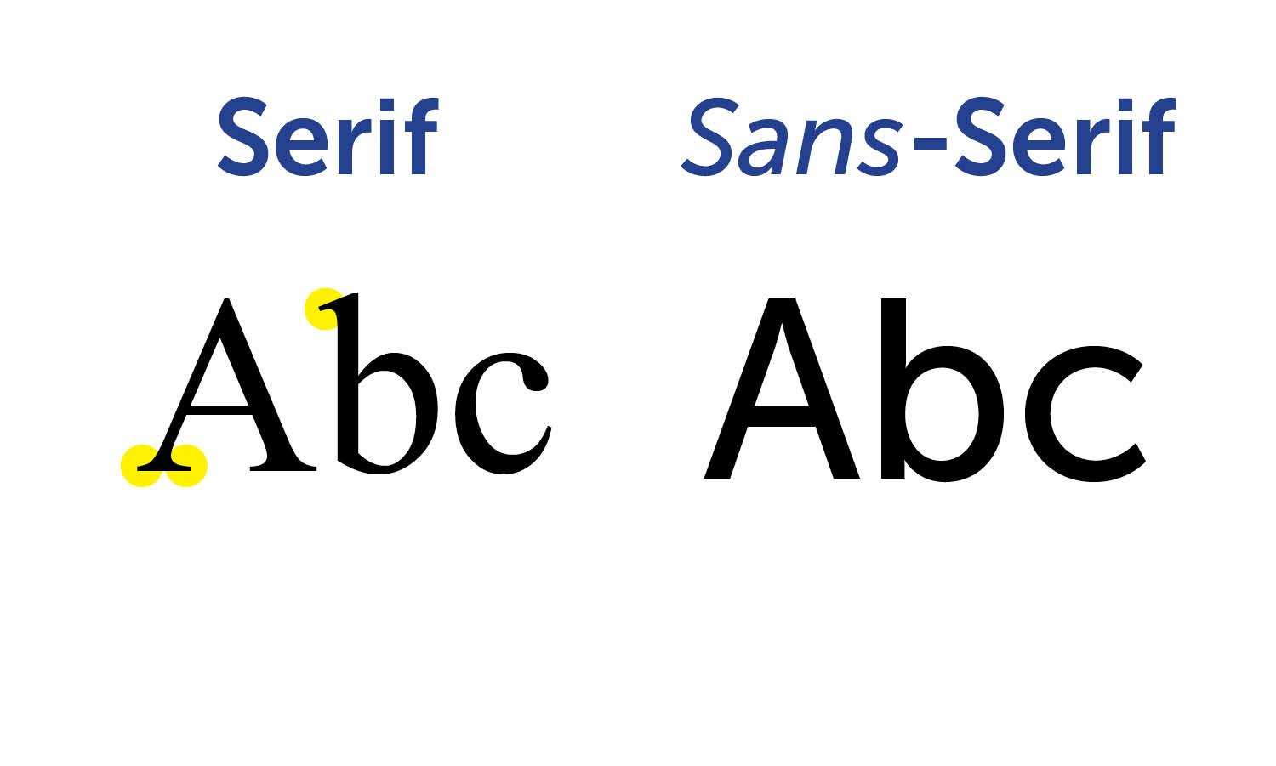

Fonts may be display fonts, designed for headlines, or text fonts, designed for large bodies of smaller text.

When measuring font size, there are two key areas to focus on

**The body size**: Which measures the full height of letters, from the bottom of the descenders (Part of the character that lies below the baseline) to the top of the ascenders( part of the character that lies above the baseline ) and three additional gutter spaces above and below.

**X-Height:** It is the distance between the baseline of a line of character. For lower case characters it's the top of the main body height excluding the spacing or ascenders or descenders. X-Height is a huge factor in typeface regarding readability.

The following graphic summarizes the key parts: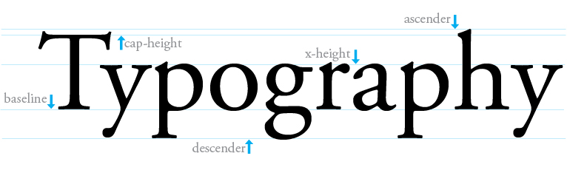

# Research Summaries

OpenDyslexic is a free font face designed to mitigate some of the common reading errors caused by dyslexia. The font was created by a dyslexic and software developer Abelardo Gonzalez, who released it under an open-source license. The design for the font is based on that of DejaVu Sans, also open-source.

Like many dyslexia-intervention font-faces, most notably Dyslexia or even DejaVu Sans. OpenDyslexic furthers the research of Dyslexia, which more of a reading aid, but it is to be noted that this is not a cure for dyslexia even though it's super popular.

The typeface includes regular, bold, italic, bold-italic, and monospaced font styles. In 2012, Gonzalez explained his motivation to the BBC: "**I had seen similar fonts, but at the time they were completely unaffordable and so impractical as far as costs go.[1]**"

There are many reports of the positive impacts of using OpenDyslexic in both traditional media and the within online forms and schools. Currently, as of 7 February 2016, there is no research paper or text-based paper on the effect of the OpenDyslexic that shows that the OpenDyslexic to be effective with English readers with dyslexia.

Currently, two major studies have investigated the effect of specialized fonts with students with dyslexia. One paper by Rello and Baeza-Yates wrote in 2013 measured eye-tracking recordings of Spanish readers aged between 11 and 50 years of age with dyslexia and found that OpenDyslexic did not hugely improve reading time nor shorten eye fixation.

In the second paper, Masters student Renske de Leeuw (2010) compared Arial with Dyslexie, she took 21 Dutch students with dyslexia as her sample group. She found that Dyslexie did not lead to quicker reading. She found it helped some students make less dyslexia-related errors.

Currently, there is a lack of evidence that a “dyslexia-friendly” font can make a difference to reading rate and accuracy for students with dyslexia, so stated earlier this paper will focus on the effects of the OpenDyslexia and its use for web accessibility.

Looking at the history of typography and the changing face of a type for digital displays. One study by Boyarski in 1998 examined the varying features of legacy fonts and modern typefaces designed for digital displays. This study wasn't planned to determine which fonts were better than others regarding readability. It did offer a scientific way to discern which features of new typefaces for dyslexics and which was to be on allow them to be more easily read on screen.

The OpenDyslexic font was made with the goal of helping with some of the symptoms of dyslexia. The font is based on the concept that the letters are heavy weighted bottoms to indicate direction. This aids in recognizing the correct letter and which part of the letter is down as it helps your brain from rotating them. Consistently weighted bottoms can also contribute to reinforcing the line of text.

The unique shape of the each letter in the openDyslexic font can help prevent confusion through flipping and swapping as the font is unlike that of other fonts the brain is seen before.

As you can see below.

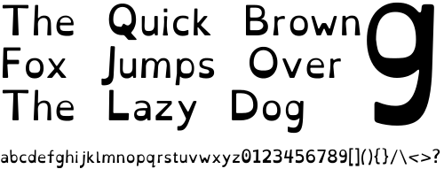

In the paper co-authored by Rello, she noted that dyslexia is a visual reading disability. It is characterized by having difficulties with fluent word recognition and commonly having poor spelling. Also, in the paper it is estimated to affect 10% of the population in the US. During her research for the paper, she looked into how different algorithms could be used to replace words with more common synonyms that are hard or confusing for dyslexics.

She looked into using eye tracking and facial expression analysis to discover what a dyslexia-friendly Web would be.There are already dozens of fonts made available that claim being dyslexia-friendly. This was one of the first times that HCI techniques were used to test the impact of Key interface design elements group sample of people with dyslexia.

The list of variables stated in Rello's experiments was very complete. Ranging from paragraph spacing, character spacing, line spacing to the font size and type. Also touched on was the column width, gray scales and color pairs.

A summarized version of Rello's findings is summarized in an upcoming paper in which she details visual details that make reading online much easier for dyslexics. One great example is how she learned that larger the font size, the better, "’18 pt’ seemed to be the optimal setting" she stated.

Another significant highlight from the paper was font types; she concluded that italics tended to have an enormous negative impact. She noticed that sans serif, monospaced and Roman font styles significantly improved the reading performance of those with dyslexia.

She stated in the report, and I would agree that the use of the following font Helvetica, Courier and Computer Modern Unicode are excellent typefaces to make sure your website is dyslexia-friendly.

# Colors

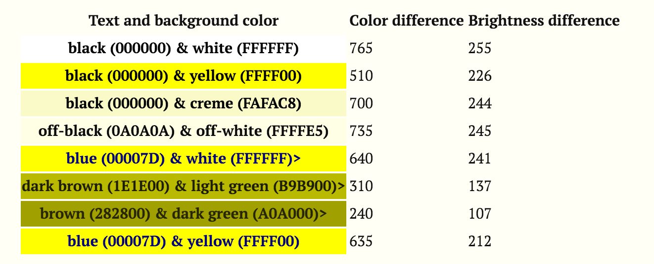

Another huge area regarding web accessibility is colors. Looking at the research report by the W3C communities (Web developers who make the W3C specifications).

In the study, they analyze how the aspects of text customization, text and background colors can improve readability of people with dyslexia.

In previous studies, it came to light that particular text and background color combinations can be beneficial for reading on the screen for those with dyslexia.

Several text customization suggestions agree that user with dyslexia prefer lower brightness and color differences among with text and background compared the average user (British Dyslexia Association, 2012). To be aware that the relationship between this preference and the minimum color luminosity ratio directed by the W3C has not been studied.

In the study taken by the W3C, they tested previous recommendations and then compared them with the W3C algorithm (The W3C algorithm suggests to avoid brightness differences less than 125 and color differences less than 500). The tests were done on a controlled group. It is shown that the user performance and preferences, among the different color values across people with and without dyslexia.

In the report, the areas of focus were broken by into the following area.

The performance, measured in reading time. Preferences, represented by the percentage of the participants choice.

Shorter fixations are preferred to longer ones, as according to other studies, Readers pause longer at points where processing loads are larger.

In their results, it was evident the greatest difference among groups is on the black & white pair. Most of the users tested who didn't have dyslexia (32.5%) preferred the color mixture and only 13.5% of people with dyslexia choose black text on white background .

The approach used for testing was so they can separate accessibility needs and personal preferences which they frequently mixed in recommendations regarding colors and readability.

The tests were composed of two parts:

1. set of texts to be read with the use of the eye-tracking. To study the reading performance.
2. A survey to collect the user's preferences, which I also did and can be seen later.

They distinguish the aspects of the textural customization which allowed readers with dyslexia to read more actually and optional suggestions regretting their preferences for the textual custom.

They were distinguish the aspects of text customization which allows readers with dyslexia to read more effectively and optional suggestions regarding their preferences.

There are several things to note about these experiments which include, the color pairs were displayed in a random order but not in a counterbalanced orderer. It isn't certain if some of the results are affected by the position of the textual fragments on the screen.

More highlights include:

1. The texts used are too small to draw firm conclusions.
2. The texts were alone on the screen. Thus, the researchers couldn't predict the color effect regarding other reading contexts such as web browsing.

The outcome of the results from the said paper did not match the WC3 algorithm. Brown and Dark presented high fixation for both groups; that was second and third highest for people without and with dyslexia.Also hardly selected by the users, with only 4.55% without dyslexia and 0.99% of the users with dyslexia)

What came as a shock to both the researcher and myself was that the pair combination was that the pair of dark brown and light green which is very similar to the color hue but different from the brown and dark green. Regarding brightness and color contrast that presents the lowest and second lowest fixations duration for people with dyslexia and without dyslexia.

The results suggest that text customisation preferences need to be complemented by measured data from actual reading performance since there is no correlation stated between the reading performance and the personal choices the user with dyslexia.

Also reported in the research was the use of the colors should be taken into consideration by UX developers. Noted even if the users with dyslexia seem to be reading faster using lower color contrasts colors than the control group of users these are not less than the W3C algorithm.

# My Research

As stated in the report I am a big support for the openDyslexic font and helping people with dyslexia, but that's another story.

What I did was follow the same methods the other papers used, I researched and developed a survey to help better understand if the research given had the same effect as the other reports and papers cited had.

I developed the survey which is still available online (see references at the bottom). It consisted of 12 questions which ranged in from details for age right down to what color combinations they used and preferred to use. Even at one stage showing them both aerial and comic sans long side a photo of openDyslexic and asking them to pick which one they prefore better.

In total, I got 43 people to take the survey by posting the link on Reddit sub categories for both dyslexia and web design. I allowed for a section for personal comments as if I can get a better understanding of what the user thought of the fonts. One user wrote " I don't like using OpenDyslexic all the time because I feel like It's not very discreet, using it would be immediately obvious to everyone that I was "different" "

For the most part, the results were the same as that of the papers cited, but within the results, it became apparent that the W3C results matched and that the results were mixed as dyslexia is different from person to person. The importance of font size and choices of color and font come to light, as it should that most people who were surveyed didn't stick to the standard 12px body but performed the 18px body size.

# Conclusion

The results of the existing research and the research of my own into the use of open dyslexics utilization and web accessibility for dyslexics can be put into effect by developers to improve the readability of their applications both software, website or web application for those with dyslexia.

Some basic recommendations would include:

1. Choose a common font with recognizable letter forms for large bodies of text, such the opendyslexic font, comic sans or arial.
2. Set the body text size to least 14 px, instead of the existing 12px.
3. Present blocks of texts in columns; don’t let text span the entire length of the screen on a widescreen display, allowing for better use of whitespace.
4. Choose text and background colors with a high luminance contrast, or better yet allow the user to select the combination.
5. Use lower case letters. Avoid unnecessary use of capitals. Using all capital letters can make it harder to read, and it can also appear that you are shouting at the reader.

Following the suggestions, it's worth noting that future studies for the typography for those with dyslexia has multiple avenues for more research. In my thoughts, one direction for future research would be an in to combine suggestions that arose from the existing studies and see if the optimization of font, color, and use of white space improve reading comprehension, passage legibility and the overall experience for the user with dyslexia.

Any studies in the field of fonts that claim to address where it helps with some of the symptoms of dyslexia.

In OpenDyslexica's cause research can be about if the effect about letters which have been heavy weighted bottoms to indicate direction, work better.

They also state that because of this you will figure out fast which part of the letter is down. This helps in spotting the correct letter and sometimes contributes to keeping the users brain from rotating them around. Consistently weighted bottoms can also contribute to reinforcing the line of text. The unique shapes of each letter can help prevent confusion through flipping and swapping. These features can be tested and researched.

As its started, the research into dyslexia and typography is comprehensive and range and should be researched even more.

As stated before when developing for the use of fonts web accessibility always provide users with several options so that they can customize the website to suit their needs.

1. "The free 'gravity' font that could make reading ... - Daily Mail." 2012. 5 Apr. 2016 <<http://www.dailymail.co.uk/sciencetech/article-2214678/The-free-gravity-font-make-reading-online-easier-dyslexia-sufferers.html>>